Standard of Care Report
Generalized Myasthenia Gravis
Based on 7 FDA-approved drugs · June 2026

Executive Summary
- Generalized myasthenia gravis (gMG) is an autoimmune neuromuscular junction disorder causing fluctuating weakness; current FDA-approved targeted therapies mainly treat antibody-positive disease and are generally layered onto background symptomatic and immunosuppressive therapy rather than replacing it outright [G1][G2].
- Treatment choice is now largely between FcRn blockers and complement inhibitors, with route, speed, biomarker eligibility, infection risk, and convenience driving selection [G1][G2].

Top drugs & classes
- FcRn blockers are leading options for broad antibody-positive gMG because they rapidly lower pathogenic IgG. Nipocalimab (FcRn-blocking IgG1 mAb) is approved for AChR- or MuSK-positive patients aged ≥12 years and improved MG-ADL by -4.7 vs -3.3 and QMG by -4.9 vs -2.1 vs placebo at Weeks 22–24 in Study 1[3][G1].
- Efgartigimod alfa (FcRn-binding IgG1-derived Fc fragment) remains a major adult AChR-positive option; in Study 1, MG-ADL responders were 67.7% vs 29.7% and QMG responders 63.1% vs 14.1% vs placebo[7][G1].
- Efgartigimod alfa/hyaluronidase provides a more convenient subcutaneous FcRn option for adult AChR-positive gMG; efficacy is supported by pharmacodynamic bridging showing comparable AChR-antibody reduction to IV efgartigimod, with self-administration possible via prefilled syringe[9][G1].
- Rozanolixizumab (FcRn-blocking humanized IgG4 mAb) is the other key SC FcRn agent for adult AChR- or MuSK-positive gMG; MG-ADL change at Day 43 was -3.4 vs -0.8 and QMG -5.4 to -6.7 vs -1.9 vs placebo[4][G1].
- Complement inhibitors are especially important in AChR-positive refractory/severe disease. Ravulizumab (anti-C5 mAb) offers the lowest maintenance frequency, improving MG-ADL -3.1 vs -1.4 and QMG -2.8 vs -0.8 at Week 26[6]. Eculizumab (anti-C5 mAb) improved MG-ADL -4.2 vs -2.3 and QMG -4.6 vs -1.6 in refractory AChR-positive gMG[2]. Zilucoplan (C5-binding macrocyclic peptide) is the self-injected daily complement option, with MG-ADL -4.39 vs -2.30 and QMG -6.19 vs -3.25 at Week 12[5][G2].

Key unmet needs
- Most approved drugs are restricted by biomarker status: complement inhibitors are AChR-positive only, while some FcRn agents are adult-only and pediatric access remains uneven[2][6][4][G1].
- Safety remains limiting: FcRn blockers raise infection risk and complicate vaccination/live vaccines; complement inhibitors add serious meningococcal infection risk plus REMS burden[3][2][6][5][G2].
- No current targeted therapy fully solves durability/convenience/cost: some require cyclic retreatment, weekly infusions, or even daily injections, and direct comparative data are lacking [G1][G2].

Glossary
AChR (Acetylcholine Receptor):: The main autoantigen in the most common form of generalized myasthenia gravis, where pathogenic antibodies target the acetylcholine receptor at the neuromuscular junction. AChR-antibody positivity is a key biomarker used to determine eligibility for several targeted therapies and is central to disease biology.
C5 (Complement Component 5):: A terminal complement protein that, when cleaved, drives formation of the membrane attack complex and contributes to neuromuscular junction damage in AChR-antibody–positive generalized myasthenia gravis. It is the key biomarker target for complement inhibitor therapies in this disease.
FcRn (Neonatal Fc Receptor):: A receptor that protects IgG antibodies from degradation and thereby prolongs their circulation in the blood. In generalized myasthenia gravis, blocking FcRn lowers total IgG, including pathogenic autoantibodies, making it an important therapeutic target and class-defining abbreviation.
FcRn blocker (Neonatal Fc Receptor blocker):: A drug class that inhibits FcRn to accelerate removal of circulating IgG antibodies. In generalized myasthenia gravis, these agents are used to reduce pathogenic autoantibodies and are particularly relevant across antibody-positive subtypes.
IgG (Immunoglobulin G):: The main antibody class involved in most pathogenic autoantibody responses in generalized myasthenia gravis. FcRn-targeted therapies work by lowering circulating IgG, which can reduce disease-driving antibodies such as those against AChR or MuSK.
mAb (Monoclonal Antibody):: A therapeutic biologic made to bind a specific molecular target with high specificity. In generalized myasthenia gravis, several targeted therapies are mAbs directed at FcRn or complement proteins.
MG-ADL (Myasthenia Gravis Activities of Daily Living):: An 8-item patient-reported scale that measures how myasthenia gravis symptoms affect everyday functions such as speaking, chewing, swallowing, breathing, and limb activity. It is one of the most important efficacy endpoints in generalized myasthenia gravis trials because it captures symptom burden from the patient perspective.
MGFA (Myasthenia Gravis Foundation of America classification):: A clinical severity classification system that categorizes myasthenia gravis based on the distribution and severity of muscle weakness. In trials and treatment discussions, MGFA class helps define baseline disease severity and eligible patient populations.
MuSK (Muscle-Specific Kinase):: A protein at the neuromuscular junction that is targeted by autoantibodies in a distinct subgroup of generalized myasthenia gravis. MuSK-antibody positivity is an important biomarker because it identifies a biologically different subtype and influences which targeted therapies are appropriate.
QMG (Quantitative Myasthenia Gravis):: A clinician-assessed scale that quantitatively measures muscle weakness across several domains in myasthenia gravis. It is a standard efficacy endpoint in generalized myasthenia gravis trials and complements MG-ADL by providing an objective assessment of physical impairment.
QMG responder (Quantitative Myasthenia Gravis responder):: A trial endpoint describing a patient who achieves a prespecified clinically meaningful improvement in QMG score, often a reduction of several points from baseline. In generalized myasthenia gravis studies, responder analyses help show how many patients experience meaningful objective improvement in weakness.

Treatment Algorithm / Sequencing
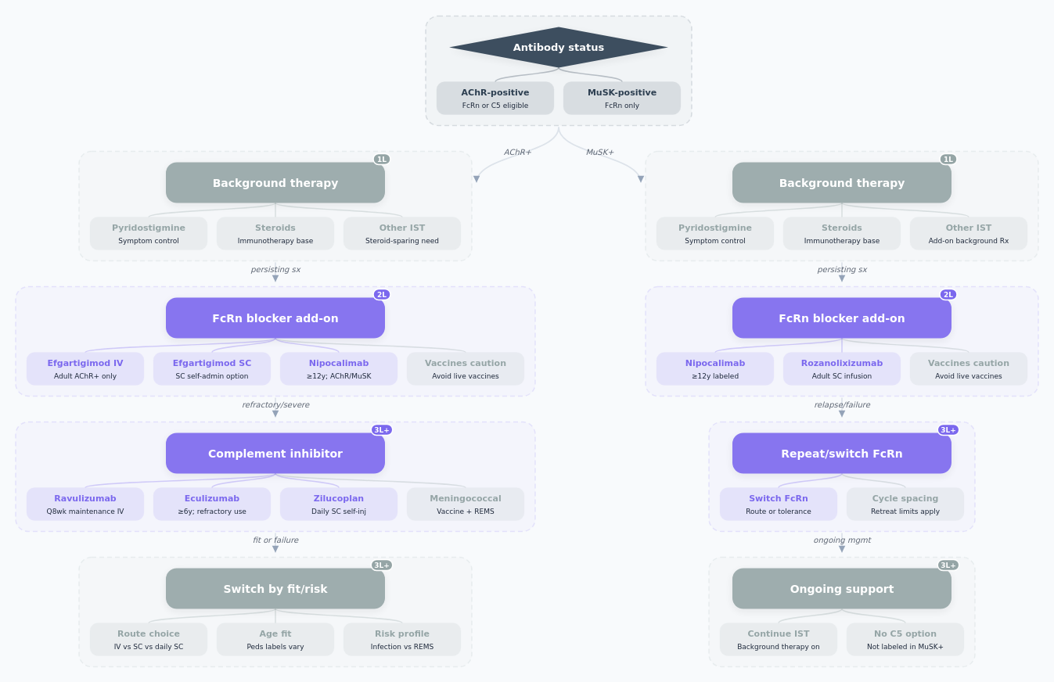
For most patients with symptomatic gMG, guidelines start with acetylcholinesterase inhibition and background immunotherapy/corticosteroids as needed; targeted biologic therapy is generally added for persistent moderate-to-severe generalized disease, treatment-refractory disease, or when steroid-sparing is needed [G1][G2]. Among FDA-approved targeted agents, sequencing is usually driven first by antibody status and second by risk/convenience [G1].
For AChR-positive disease, both FcRn blockers and complement inhibitors are reasonable targeted options [G1][G2]. In current practice, many clinicians favor an FcRn blocker first when flexibility across severity, cyclic use, or easier avoidance of meningococcal REMS is preferred; choices include IV efgartigimod, SC efgartigimod/hyaluronidase, rozanolixizumab, or nipocalimab depending on age, route preference, and MuSK eligibility[7][9][4][3]. Complement inhibition may be preferred earlier for clearly refractory AChR-positive disease, especially when sustained control is prioritized and meningococcal vaccination/REMS logistics are acceptable[2][6][5][G2].
For MuSK-positive disease, current FDA options are FcRn blockers only: nipocalimab and rozanolixizumab are directly labeled; complement inhibitors are not[3][4][G1].
Important deviations from a rigid sequence:
- Pediatric/adolescent: nipocalimab (≥12 years) and eculizumab (AChR+, ≥6 years) may move earlier because labeled alternatives are limited[3][2].
- Need for self-administration: SC efgartigimod/hyaluronidase prefilled syringe or daily zilucoplan can outrank infusion therapies[9][5].
- Need for lowest visit frequency: ravulizumab every 8 weeks can outrank eculizumab every 2 weeks[6][2].
Practical caveats: vaccinate before FcRn cycles and avoid live vaccines during treatment[7][3]; meningococcal vaccination is mandatory before complement inhibitors, with antibacterial prophylaxis if urgent start is necessary[2][6][5]. Efgartigimod retreatment sooner than 50 days from start of prior cycle and rozanolixizumab sooner than 63 days from start of prior cycle is not established[7][4].

Drug Classes
Drug Class | Mechanism of Action | Drugs | Class Positioning
FcRn blockers | Bind neonatal Fc receptor (FcRn), reducing circulating IgG and pathogenic autoantibodies [7][3] | • efgartigimod alfa[7]  • efgartigimod alfa, hyaluronidase (human recombinant)[9]  • nipocalimab[3]  • rozanolixizumab[4] | Broadly favored targeted class for antibody-positive gMG because they are usable in both AChR-positive disease and, for nipocalimab/rozanolixizumab, MuSK-positive disease as well [G1]. They avoid complement-REMS burden but still require infection vigilance and live-vaccine avoidance[3][4].
Complement C5 inhibitors | Inhibit C5 cleavage to C5a/C5b and prevent terminal complement complex C5b-9 formation at the neuromuscular junction[2][6][5] | • eculizumab[2]  • ravulizumab[6]  • zilucoplan[5] | Often reserved or prioritized for AChR-positive refractory/severe gMG because of strong efficacy and mechanistic fit, but limited by meningococcal vaccination requirements, REMS, and serious infection risk [G2]. Ravulizumab offers the lowest maintenance frequency; zilucoplan offers self-injection but requires daily dosing[6][5].

Main Drugs and Key FDA-Label Efficacy/Safety
Drug | Class | Route | Key Indication | Efficacy Results | Safety Results | SoC Fit
efgartigimod alfa | FcRn blocker | IV | Adult gMG, anti-AChR antibody positive | • Study 1 (targeted add-on, adults, AChR+, MGFA II-IV): MG-ADL responders cycle 1 67.7% vs 29.7%; OR 4.951; p<0.0001[7]  • Study 1 (targeted add-on, adults, AChR+): QMG responders cycle 1 63.1% vs 14.1%; OR 10.842; p<0.0001[7] | Respiratory tract infection 33% vs 29%, headache 32% vs 29%, UTI 10% vs 5%, paresthesia 7% vs 5%, myalgia 6% vs 1%; below-normal WBC 12% vs 5%, lymphocytes 28% vs 19%, neutrophils 13% vs 6%; postmarketing anaphylaxis/hypotension reported[7] | Leading adult AChR+ FcRn option
efgartigimod alfa, hyaluronidase (human recombinant) | FcRn blocker + hyaluronidase | SC | Adult gMG, anti-AChR antibody positive | • Study 1 program anchor (targeted add-on, adults, AChR+, IV reference): MG-ADL responders 67.7% vs 29.7%; QMG responders 63.1% vs 14.1%[9]  • Study 2 (SC bridging, adults with gMG): maximum mean AChR-Ab reduction at Week 4 62.2% with SC vs 59.7% with IV; 90% CIs within 80%-125% for PD comparability[9] | Injection-site reactions 38% in gMG Study 2; common AEs ≥10% were injection-site reactions and headache; injection-site reactions mild/moderate and did not lead to discontinuation in Study 2/OLE; IV-reference common AEs included respiratory tract infection 33% vs 29%, headache 32% vs 29%, UTI 10% vs 5%[9] | Convenient SC option for adult AChR+
nipocalimab | FcRn blocker | IV | gMG in adults and pediatric patients ≥12 years, anti-AChR or anti-MuSK positive | • Study 1 (targeted add-on, adults, AChR+/MuSK+): MG-ADL LS mean change Weeks 22-24 -4.7 vs -3.3; difference -1.5 (95% CI -2.4 to -0.5), p=0.002[3]  • Study 1 (targeted add-on, adults, AChR+/MuSK+): QMG LS mean change Weeks 22 & 24 -4.9 vs -2.1; difference -2.8 (95% CI -4.2 to -1.4), p<0.001[3] | Common AEs: respiratory tract infection 18% vs 13%, peripheral edema 12% vs 2%, muscle spasm 12% vs 3%, hypersensitivity 8% vs 7%, abdominal pain 8% vs 3%; serious infections 7% across Study 1+extension; infusion-related reactions 11%; hypersensitivity reactions 16%; discontinuation from infection 1% and urticaria in 1 patient[3] | Broad-label FcRn option, incl MuSK and adolescents
rozanolixizumab | FcRn blocker | SC infusion | Adult gMG, anti-AChR or anti-MuSK positive | • Study 1 (targeted add-on, adults, AChR+/MuSK+): MG-ADL Day 43 LS mean change -3.4 vs -0.8 placebo; difference -2.6 for ~7 mg/kg and -2.6 for ~10 mg/kg, both p<0.001[4]  • Study 1 (targeted add-on, adults, AChR+/MuSK+): QMG Day 43 LS mean change -5.4 and -6.7 vs -1.9 placebo; differences -3.5 and -4.8, both p<0.001[4] | Headache 44% vs 19%, any infection 23% vs 19%, diarrhea 20% vs 13%, pyrexia 17% vs 2%, hypersensitivity 11% vs 5%, nausea 10% vs 8%, administration-site reactions 8% vs 3%; serious infections 4% overall; 3 fatal pneumonias in broader program; aseptic meningitis reported[4] | Strong adult FcRn option; useful in MuSK+
eculizumab | Complement C5 inhibitor | IV | gMG in adult and pediatric patients ≥6 years, anti-AChR antibody positive | • ECU-MG-301 (refractory targeted add-on, adults, AChR+): MG-ADL LS mean change at Week 26 -4.2 vs -2.3; difference -1.9 (95% CI -3.3 to -0.6), p=0.006[2]  • ECU-MG-301 (refractory targeted add-on, adults, AChR+): QMG LS mean change at Week 26 -4.6 vs -1.6; difference -3.0 (95% CI -4.6 to -1.3), p=0.001[2] | gMG AEs: musculoskeletal pain 15% vs 8%, abdominal pain 8% vs 5%, peripheral edema 8% vs 5%, herpes simplex 8% vs 2%, contusion 8% vs 3%, pyrexia 7% vs 3%; major risk is serious/fatal meningococcal infection despite vaccination and REMS restriction[2] | Refractory AChR+ disease; key complement option
ravulizumab | Complement C5 inhibitor | IV | Adult gMG, anti-AChR antibody positive | • ALXN1210-MG-306 (targeted add-on, adults, AChR+): MG-ADL Week 26 LS mean change -3.1 vs -1.4; treatment effect -1.6 (95% CI -2.6 to -0.7), p<0.001[6]  • ALXN1210-MG-306 (targeted add-on, adults, AChR+): QMG Week 26 LS mean change -2.8 vs -0.8; treatment effect -2.0 (95% CI -3.2 to -0.8), p<0.001[6]  • ALXN1210-MG-306: MG-ADL responders ≥3-point improvement 56.7% vs 34.1%; QMG responders ≥5-point improvement 30.0% vs 11.3%, p=0.005[6] | gMG common AEs: diarrhea 15% vs 12%, upper respiratory tract infection 14% vs 8%, dizziness 9% vs 3%, back pain 8% vs 6%, abdominal pain 6% vs 0%, UTI 6% vs 4%; serious adverse reactions 23% vs 16%, with infections 9% vs 4%; one fatal COVID-19 pneumonia; meningococcal risk/REMS[6] | Preferred long-interval complement inhibitor
zilucoplan | Complement C5 inhibitor | SC | Adult gMG, anti-AChR antibody positive | • Study 1 (targeted add-on, adults, AChR+): MG-ADL Week 12 LS mean change -4.39 vs -2.30; difference -2.09 (95% CI -3.24 to -0.95), p<0.001[5]  • Study 1 (targeted add-on, adults, AChR+): QMG Week 12 LS mean change -6.19 vs -3.25; difference -2.94 (95% CI -4.39 to -1.49), p<0.001[5]  • Study 1: MG-ADL responders ≥3-point improvement 73.1% vs 46.1%, p<0.001; QMG responders ≥5-point improvement 58% vs 33%, p=0.0012[5] | Injection-site reactions 29% vs 16%, URTI 14% vs 7%, diarrhea 11% vs 2%, UTI 8% vs 5%, nausea/vomiting 8% vs 7%, lipase increased 7% vs 0%, amylase increased 5% vs 1%; pancreatitis/pancreatic cysts reported in extension; serious meningococcal risk and REMS[5] | Self-injected complement option; fast, potent but daily

Special Populations

Pediatric
- Best options: Eculizumab is the earliest approved targeted drug for gMG (AChR-positive, age ≥6 years)[2]. Nipocalimab is approved for AChR- or MuSK-positive patients ≥12 years and had pediatric PK/safety support[3].
- Earliest approved age: eculizumab at 6 years[2].
- Restrictions: Efgartigimod IV/SC, rozanolixizumab, ravulizumab, and zilucoplan do not have established pediatric gMG use[7][9][4][6][5].
- Complement inhibitors require meningococcal vaccination/REMS[2].

Pregnancy
- Human pregnancy data are limited for FcRn blockers and several labels warn that lowering maternal IgG may reduce passive neonatal immunity; live vaccines in exposed infants may need special consideration[7][9][3].
- Eculizumab has the most reassuring human experience among these agents, with pooled exposure data in >300 pregnancies with live births not suggesting a specific safety signal, though data remain limited[2].
- Ravulizumab, rozanolixizumab, zilucoplan, nipocalimab: no adequate human-risk definition; animal findings raise concern[6][4][5][3].

Lactation
- Eculizumab has limited published data not detecting drug in human milk, but infant-risk certainty is still limited[2].
- Nipocalimab is excreted in human colostrum/breastmilk in limited data[3].
- Efgartigimod products, rozanolixizumab, zilucoplan: no adequate human milk data; maternal IgG is known to be present in milk[7][9][4][5].
- Ravulizumab label advises discontinuing breastfeeding during treatment and for 8 months after the final dose[6].

Elderly
- No targeted gMG drug has strong elderly-specific evidence; most labels state insufficient numbers ≥65 years to determine differential response[7][3][4][5].
- Eculizumab and ravulizumab include some older-adult exposure without clear age-related differences, but numbers remain limited[2][6].
- In practice, selection is driven more by comorbidity burden: infection susceptibility may favor caution with FcRn blockers, while meningococcal-risk/REMS burden may complicate complement inhibitors [G1][G2].

